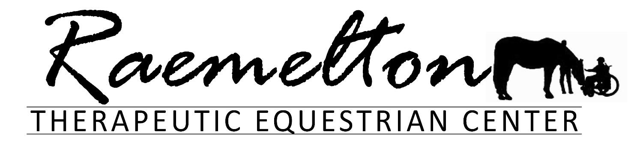

Dear Prospective Volunteer,

Thank you for your interest in volunteering at Raemelton Therapeutic Equestrian Center. We hope that it will be an enjoyable and fulfilling experience for you!

In this packet, you will find a volunteer application, along with a background release (for volunteers over the age of 18). Please complete the form and return it prior to your beginning date.

All new volunteers are required to attend Level One Training. This training is designed to address policies, procedures, and expectations. We will have them scheduled throughout the year; they are typically 30-40 minutes in length. Please be sure to check with staff for scheduled dates and times. For those who are interested in becoming horse leaders in class, we will have Level Two training scheduled periodically throughout the year. Dates and times of all training will be posted on the whiteboard in the vestibule of the main barn and in the grooming/tacking barn.

For prospective volunteers who are over the age of 18, you will be required to submit a background check. Checks are conducted at the Sheriff’s Department at 597 Park Avenue East, Mansfield, Ohio 44905. Volunteers under the age of 18 will not be subject to a background check.

You will also find a volunteer information handbook in this packet. It contains information about volunteering – including helpful hints and dress code – and contact information for staff. If you are unable to attend on your scheduled day(s)/time(s), please contact the office or a staff member so we can get a substitute for you.

CLASS VOLUNTEERS: Classes are either ½ hour or one hour in length. If you would like to groom/tack horses, please plan to be here 30 minutes prior to class start time. If you do not plan to groom and tack, please plan to be here 10 minutes before class begins. Typically, a session is 10 weeks in length, and we ask that if you are committing to a class, you keep the same day/time for the duration of the session. We have classes that run throughout the day from 10 am – 6:30 pm Monday through Friday. We do our best to find a class time and day that works best with your schedule.

BARN VOLUNTEERS:
The horses and barn are a 365-day-a-year endeavor. Typically, there are morning and evening shifts. We ask for one hour, once a week – however, if you would like to spend more time, we are appreciative.

You do not need previous horse experience to volunteer! We provide training for you. We want it to be a great learning experience for you, any questions you have, please ask! It is our goal that you are comfortable and confident in all tasks.

Without volunteers like you, we would be unable to provide programs for our students. Thank you for all you do!

Hannah Nelson,
Executive Director

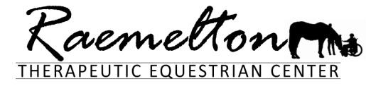
569 SOUTH TRIMBLE ROAD
MANSFIELD, OHIO 44906
419.756.0040
raemelton@raemelton.org raemelton.org

VOLUNTEER APPLICATION

Name ___________________________________________________________________ Date ___________________

Address _______________________________________________________________________________________________

City __________________________________________________________ State __________________ Zip ______________

Cell Phone ( )___________________________________ Email ______________________________________________

Home Phone ( )__________________________ Preferred Contact: Cell Email Text Home Call

Date of Birth ______________________________ (Minors under the age of 18 must have parent/guardian consent to volunteer)

Emergency Contact ________________________________________ Relationship _____________________

Home Phone ( )_______________________________ Cell ( )_____________________________

Do you need volunteer hour verification for work or school? ________ If yes, how many hours? _________

Name of employer or school _________________________________________________________________
How did you hear about us? _________________________________________________________________
Do you have experience with: Horses? ______________ People with disabilities? ___________________
Have you volunteered here or anywhere else? ____________ If yes, where? _________________________
What types of duties did you perform as a volunteer?____________________________________________
_________________________________________________________________________________________

As a class volunteer, you will be asked to commit to at least one hour per week, every week, for an entire session. Sessions typically run for a ten-week period. Are you able to commit? Yes_____ No______
As a volunteer, are you more interested in:
Working with students in classes as a side walker/horse leader _________ Barn work ____________
General maintenance (mowing/weeding) _______ General cleaning ________

What is your preferred availability? _________________________________________________________

I have received a copy of the Volunteer Information Handbook and understand that in order to volunteer I must attend a LEVEL I Training.

BACKGROUND INFORMATION:
RTEC reserves the right to refuse volunteer opportunities to persons convicted of certain crimes;
including but not limited to, convictions for crimes committed upon persons with disabilities, children or animals.

Volunteers over the age of 18 are required to submit to a criminal background check.

Have you ever been convicted of a crime? Yes _____ No______

If yes, explain _____________________________________________________________________________

I, ______________________________________, authorize Raemelton Therapeutic Equestrian Center to receive information from any law enforcement agency of this state or any other state or federal government, to the extent permitted by state and federal law, pertaining to any convictions I may have for violations of state or federal laws, including but not limited to, convictions for crimes committed upon children or animals. I understand that such access is for the purpose of consideration of my application as a volunteer, and I expressly DO NOT authorize RTEC, its directors, officers, employees or other volunteers to disseminate this information in any way to any other individual, group, agency, organization or corporation.

I, _____________________________________, being over the age of eighteen years, understand that I am subject to fingerprinting and criminal background investigation by Raemelton Therapeutic Equestrian Center through either the Ohio Bureau of Criminal Identification & Investigation (BCI&I) or the Federal Bureau of Investigation (FBI) or a combination of both. I understand this is in compliance with Senate Bill 38, Ohio Revised Code 5104.09.

I have been a resident of Ohio for the past five years ______ (BCI check only)
I have not been a resident of Ohio for the past five years _______ (BCI/FBI check required)

I certify that I have read and understand the above statements and understand that becoming a volunteer is contingent on a satisfactory background investigation.

________________________________________________________ ____________________
Signature Date

PHOTO RELEASE:

I hereby consent and authorize the use and reproduction by Raemelton Therapeutic Equestrian Center any and all photographs and any other audiovisual materials taken of me/my son/my daughter/my ward for promotional printed material, educational activities or for any other use for the benefit of Raemelton’s program.

______________________________________________________ _____________________
Signature Date

________________________________________________________________________________ _______________________________
Parent/Guardian (If volunteer is under legal age of eighteen years of age) Date

CONFIDENTIALITY AGREEMENT:
HIPAA (Health Insurance Portability and Accountability Act) of 1996 is a federal law which protects a person’s health information from being shared with those who do not need to know. As a volunteer for Raemelton Therapeutic Equestrian Center, you will be bound by the guidelines of this law.

At no time should you: Share a student’s personal information with another, including a student’s name, diagnosis, method of payment and services received. Doing so is a violation of the HIPAA law. If you have questions regarding this law, please ask a staff member.

I understand that all information (written and verbal) about participants at Raemelton Therapeutic Equestrian Center will remain confidential and will not be shared with anyone without the expressed written consent of the participant or their legal agent (parent/guardian) if applicable.

______________________________________________________ _____________________
Signature Date

________________________________________________________________________________ _______________________________
Parent/Guardian (If volunteer is under legal age of eighteen years of age) Date

WAIVER OF LIABILITY AND CONSENT:
I hereby grant consent for the undersigned equine activity participant (as such term is defined in Ohio Revised Code 2305.321, Section A(3) and referred to herein as “Participant”) to participate in the Raemelton Therapeutic Equestrian Center program.

In addition, this document constitutes a written waiver of liability, as defined and described by Ohio Revised Code 2305.321, Sections C(1) and C(2), for the benefit of Raemelton Therapeutic Equestrian Center, Inc., its affiliates and its duly-authorized agents. Pursuant to Ohio Revised Code 2305.321, Section C(2)a, the undersigned acknowledges that there are inherent risks associated with equine activities, including but not limited to:
- The property of an equine to behave in ways that may result in injury, death or loss to person on or around equine;
- The unpredictability of an equine’s reaction to sounds, sudden movements, unfamiliar objects, persons or other animals;
- Hazards including but not limited to surface or subsurface conditions;
- A collision with another equine, another animal, a person or an object;
- The potential of an equine activity participant to act in a negligent manner that may contribute to injury, death, or loss to the person of the participant or to other persons, including but not limited to failing to maintain control over an equine or failing to act within the ability of the participant.

I have read and understand the above inherent risks, have had the opportunity to have my questions answered and understand the potential benefits and alternatives to this activity.

______________________________________________________ _____________________
Participant Signature Date

________________________________________________________________________________
Participant Printed Name

________________________________________________________________________________ _______________________________
Parent/Guardian Signature (If volunteer is under legal age of eighteen years of age) Date

_________________________________________________________________________________
Parent/Guardian Printed Name

