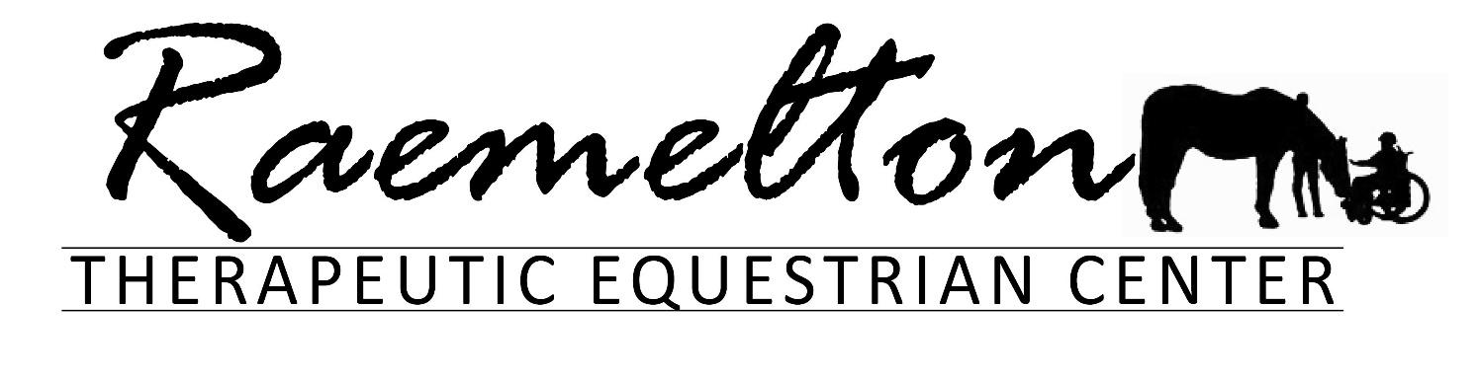

569 South Trimble Road Mansfield Ohio 44906
Volunteer Manual
Updated December 2025

Our Mission
Raemelton enhances the abilities of individuals with special needs and challenges through horse-centered therapies and activities.
Riders with impaired mobility are taught balance, coordination, and self-assurance while receiving muscle stimulation. Individuals with learning or mental disabilities are motivated to increase concentration, patience, and discipline.
The unique bond formed with a horse can also improve interpersonal relationships for those with psychological and or emotional disabilities.

By promoting the strengths that lie within both the disabled individual and his/her horse, Raemelton encourages riders to expand their abilities in a safe, yet challenging environment.

This handbook provides an overview of Raemelton Therapeutic Equestrian Centers mission, the purpose of the programs that serve our community, and how volunteers engage with our programs. This handbook also explains volunteering rules, resources, expectations, and relevant organizational policies & procedures.

Raemelton History
Raemelton Therapeutic Equestrian Center was founded in 1995 and started with 35 riders and 4 horses. We now have 17 equine partners and serve over 140 students each week between therapeutic riding and equine-facilitated learning classes. In December 2015, the organization was gifted funds to purchase 34 acres and all structures. Since the purchase, Raemelton has been able to take a leadership role in preserving this historical landmark and implementing modifications to better serve individuals with disabilities. Raemelton encourages riders to expand their abilities in a safe, yet challenging environment.

PHONE NUMBERS

OFFICE 419.756.0040
Hannah 614.506.2597
SIMONE 419.631.0820

Key Information
- Be on time – If running late or absent, please notify Hannah ASAP.
- Make sure to sign in and out on the timesheets located in the volunteer lounge or the groom/tack barn.
- Never tease, abuse, or discipline a horse. Notify the instructor or staff if any problems need to be addressed.
- Be aware of your horse at all times! No matter if you are a leader or side walker pay attention to your horse as they will use their body language to communicate. For example: If you are petting a horse on its face and the horse backs away or tries to bite you, the horse is communicating to you that the horse doesn’t like your actions and wants you to stop.
- Be mindful when on premise that all conversations can be heard by students, parents, volunteers, staff, and others. Always be aware of your conversations that might not be appropriate for others who are not staff members.
- Please be understanding and sensitive to the needs of our students.
- Remember the student should be the center of attention. Discussions between volunteers once class starts should stop until class is over.
- Once class has started, reinforce the student’s attention, and focus on the instructor. Avoid discussion between volunteers and students while the instructor is speaking.
- Assist riders but try not to do tasks for them as we want to encourage them to learn and do.
- Communication is KEY
- If the weather is warm, please bring a water bottle.
- No pets on premises (unless they are service animals).
- Smoking is permitted in your car only. DO NOT throw cigarette butts on the ground!
- Students must wear their helmets when grooming and at all times while in the arena.
- Only instructors are to mount/dismount students unless in an emergency situation.
- Under the Age of 18
Children under the age of 18 must receive approval from a parent or guardian by signing the Volunteer Waiver. Minors ages 16 and 17 may volunteer independently, with prior approval from the Volunteer Coordinator. Minors between the ages of 10 and 15 must be accompanied by an adult during all volunteer opportunities, with prior approval from the Volunteer Coordinator.
Under the Age of 18
Children under the age of 18 must receive approval from a parent or guardian by signing the Volunteer Waiver. Minors ages 16 and 17 may volunteer independently, with prior approval from the Volunteer Coordinator. Minors between the ages of 10 and 15 must be accompanied by an adult during all volunteer opportunities, with prior approval from the Volunteer Coordinator.
- Please do not leave the arena with any of the horses/ponies until ALL students are dismounted and the instructor has dismissed everyone. This is a safety issue!!

Dress Code
NO: Tube tops, spaghetti strap tank tops, camisoles, short shorts, t-shirts/sweatshirts with controversial or profane slogans. Pants should fit at the waist and/or be secured with a belt. No underwear showing!
Please remember that you are working in a barn with large animals. CLOSED-TOE SHOES ARE A MUST!
Absolutely no open-toe sandals, flip-flops, or crocs. Shoes with laces must be tied! No exceptions!

Arriving for Class

All volunteers who lead or want to groom and tack should meet in the barn no later than 30 minutes prior to class. Everyone else should arrive no later than 15 minutes before class at the groom barn. If you should be running late, please text Hannah ASAP. All volunteers must sign in/out each time you are here. There is a sign-in book in the main barn volunteer lounge and in the groom barn by the helmets. The instructor will have a list of leaders that can walk horses to the groom barn. It is best if leaders and sidewalkers groom and tack the same horse they work with in class. However, sometimes you might be asked to get another horse ready for class.

Please check the whiteboards for important updates!

From Start to Finish: What is a typical class like?

- Volunteers will sign in.
- Leaders will walk horses down to the groom barn and volunteers will groom and tack the horses.
- 5-10 minutes before class starts, horses are brought into the arena for tack check and stretched by the instructor.
- The instructor will mount the students, do another tack check, chat with the students and volunteers and the student will begin their class.
- After all students are mounted, the instructor will call each student to do another tack check.
- The instructor will then gather all students to start with stretches and the instructor will inform the class what the lesson is for the day.
- Students will work on the lesson throughout class. Volunteers should not show the students skills they have not been taught. However, volunteers can always add in other activities or change up some items with their students if needed.
- The instructor will call all students to line up for dismount and the instructor will dismount all students 10 minutes prior to the end of class. All students must keep their helmets on until they are outside of the arena.
- Leaders will lead the horses into the groom barn, volunteers (or students) will untack, and leaders will return the horses back to the barn.
- Volunteers will sign out after class.

Volunteer Positions for Class

The volunteer coordinator will notify the instructors which volunteers are trained as leaders and as sidewalkers. During the first class, instructors will notify volunteers of their position in class. To ensure consistency, the same volunteers will be in the same position, be with the same horse and student throughout the session. However, there may be times that your position or student is switched based on the current happenings in the arena, or availability of leaders and side walkers.

Side Walker
Primary Responsibilities
Sidewalkers get the most hands-on interactions with students! The first responsibility is the student. Side walkers help to maintain the student’s balance on the horse, and encourage the student to listen, focus, reinforce, and assist. The sidewalker has the ability to hinder or enhance the student’s lesson. Side walkers should inform leaders of any problems, issues or help needed during a lesson and if the leader needs to halt the horse. Communication is key. Side walkers will be instructed to either do a thigh hold or an ankle hold for the student. Some students will need minimal or no physical support. Maintaining the proper distance between the student and the horse is important. Being too far forward or behind will make it hard to assist the student and stay with the horse.

Mounting:
During mounting, the instructor will let you know if you are needed to do offsides while the student mounts. If not, wait in the arena until the students come in for their tack check after mounting. The instructor will inform you which side to walk on, and the type of hold the student receives and introduce you to the student.
Thigh Hold: Lightly place your forearm over the student’s thigh and hold onto the front of the saddle. Do not dig your arm or elbow into the rider or horse. Avoid putting your arm around the rider’s waist. During the lesson, if your arm gets sore or tired, notify the leader that you need to stop and switch sides to do the thigh hold. The leader should support the rider while the sidewalker switches sides. If needed, you can ask the instructor for help.
Ankle Hold: Lightly hold the back of the student’s shoe. This can also be done for students who don’t need support but will help the sidewalker maintain pace.

Lessons:
It is important to maintain pace beside the student’s knee. If there are two sidewalkers, designate one sidewalker to verbally reinforce the instructor. Be aware that too much input from sidewalkers can overload a student. Throughout the session you will get to know your student and learn what support the student will need. Assist the rider throughout the lesson. Always allow plenty of time for the student to process a question or task. Try NOT to do tasks or answer questions for the student but allow the student plenty of time to try to complete the task or to answer. An example of assisting the student: if the instructor is asking the student to turn right, you can gently tap the student’s right hand to signal which way to turn if the student is unsure of which direction right is. If a student starts to slip; notify the leader if they need to halt the horse, then try to verbally help the student first to allow the student to correct themselves. If the students can’t correct themselves, physically correct them. If a student is slipping and instructor help is needed, halt the horse, and ask the instructor to come over to the student. If you need to step away from a student who needs a thigh or ankle hold to assist in an activity, notify the leader to support the student while you step away. Some students prefer to talk and socialize during class instead of working on the task. Do not ignore them but redirect their focus. Never let the student lean from the horse. If the horse were to move or spook, most students can’t maintain their balance to stay on. If you can’t get the horse close enough to the object, it is OKAY for the leader or sidewalker to pick up the object for the student and then make the student stretch to you to reach the object.

Dismounting:
During dismounting, the sidewalker will stay with the student to assist in the dismounting. If the student goes to the mounting ramp; be on the off side of the horse and support the student, following all the way until the horse is halted at the mounting ramp and following the instructor’s directions. If dismounting in the arena, help the student if needed take their right foot out of the stirrup and right leg over the horse. The instructor will give you any directions necessary. Sidewalkers should walk the student to the gate.

Horse Leader
Primary Responsibilities
Your first responsibility is to maintain control of the horse! However, you must always be aware of the student, the instructor’s directions, and potential hazards in the arena. If there is a sidewalker with the student, the sidewalker will take care of the student. If there is no sidewalker, please be aware of the student also. If there are any problems or issues with you, the sidewalker, the horse, or the student, see your instructor! Never allow horses to sniff each other.
When leading a horse, NEVER drag the horse to increase pace. Some horses walk slower than others. Below is the correct and incorrect position of the leader. Leaders should keep a slower walking pace for the comfort of the student.
NEVER WRAP THE LEAD ROPE AROUND YOUR HAND, DRAPE IT OVER YOUR SHOULDER, OR ATTACH IT TO ANY PART OF YOUR BODY!
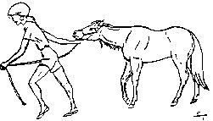
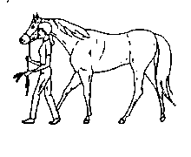


Incorrect
Correct

Mounting:
To lead the horse into the mounting ramp; walk the horse into the mounting ramp area, stop the horse and switch to lead on the offside, circle to the mounting ramp and stop, turn, and walk backward bringing the horse closest to the mounting ramp. The leader should walk between the ramp and the cones. In the event the horse is too far forward or not close enough, take the horse around again – NEVER BACK THE HORSE IN THE RAMP OR MAKE THE STUDENT STRETCH! Stand slightly to the side of the horse while the student is mounting. This serves as a psychological barrier to the horse which is less likely to move forward. Sometimes it helps to scratch the horse’s neck or speak quietly to keep the horse calm at the mounting block. Once the student has been mounted, wait for the cue from the student or the instructor to walk the horse into the arena and stop inside the arena for a tack check. The instructor will introduce you to the student and will notify you if the student should get a long lead or normal length and other important information about the student. For a student to have complete use of their reins, the lead rope should not be hanging over the reins but instead hanging between the reins.
If the student mounts inside the arena, the mounting block will be brought to the horse and the student will mount. The leader needs to keep control of the horse while the student mounts.

Never wrap the end of the lead rope around your hand. Always hold the lead rope in a figure eight. If your horse has a lead shank (lead rope with a chain), never hold the lead shank on the chain portion.

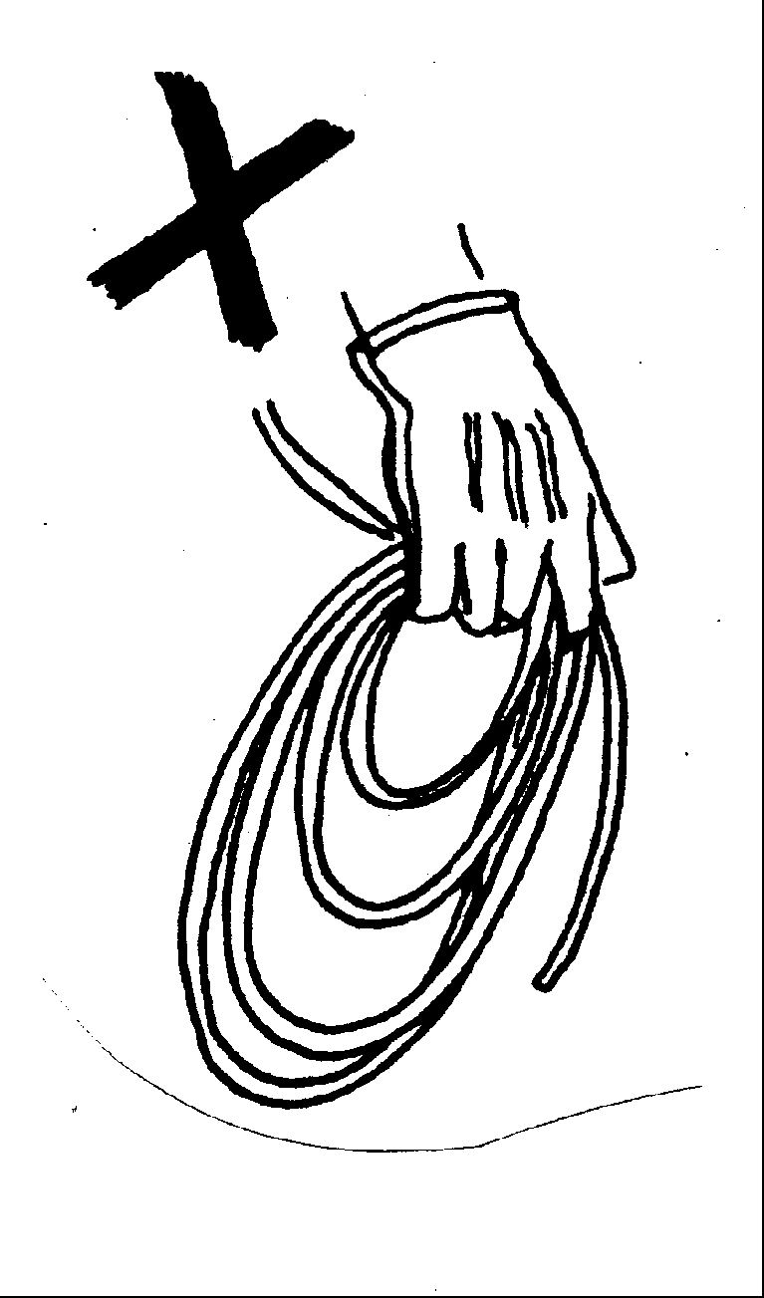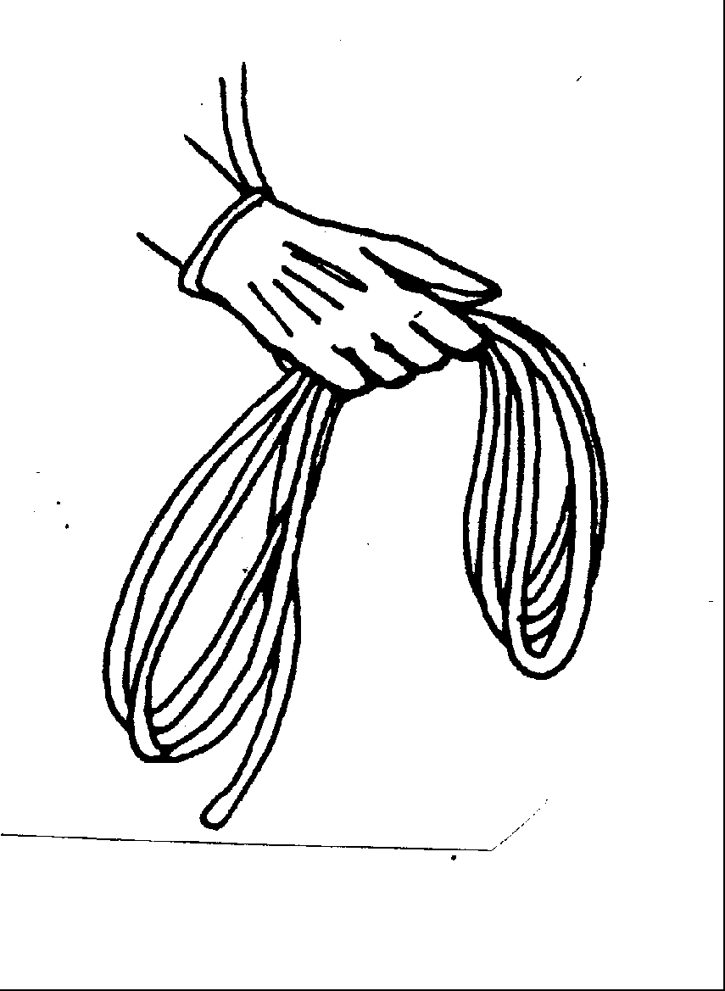
Incorrect
Correct
Lessons:
Maintain at least a two-horse distance between other horses around you. All horses have the potential to bite and kick. If your student is unable to maintain a safe distance, help the student. Always be aware of what your student is working on so as not to impede the student’s ability to perform tasks. If your horse should balk or shy, do not pull on the lead rope! Stay calm and say “Whoa”. Wait until the horse relaxes and calms. As the leader, be focused and alert to potential hazards in the arena that might frighten the horse. Leaders should always be mindful of their sidewalker and maintain enough room between the sidewalker and objects to pass. Students are encouraged to do as much as possible but safely. Never let the student lean from the horse. If the horse were to move or spook, most students can’t maintain their balance to stay on. If you can’t get the horse close enough to the object, it is OKAY for the leader or sidewalker to pick up the object for the student and then make the student stretch to you to reach the object.

Dismounting:
The same steps are followed as mounting. If dismounting at the mounting ramp, be mindful of where your student’s foot is so as not to get their foot caught between the ramp and the horse. The instructor will give you directions to assist in dismounting.

Tips for all volunteers

- Don’t steal the rider’s thunder! Many of the students need time to process which can be between 5-60 seconds. Be patient and give the students time to answer or perform a task. The ultimate goals for our students are enjoyment, growth, improvement, and success to the best of their ability.
- Do NOT teach student’s riding skills the instructor has not taught. Instructors create lesson plans for each student and work in steps. However, please step in and assist the student during the lesson on a riding skill they are supposed to be working on. If at any time you have a question, please ask the instructor.
- Never let the student lean off of the horse. If the horse were to move or spook, most students can’t maintain their balance to stay on. If you can’t get the horse close enough to the object, it is OKAY for the leader or side walker to pick up the object for the student and then make the student stretch to you to reach the object.
- No cell phone usage in the arena! If you are waiting for an important call, notify the instructor before class, do not answer the call when you are leading but instead hand off the horse to the instructor before you answer the call. Do not take photos of students or volunteers unless asked or a photo release is on file. Not everyone on premises has a photo release.
- If you feel sick or faint during class, notify the instructor right away.
- Dismounting is only done by instructors except in an emergency.
- If at any time you have a question, please ask!

Grooming Tools

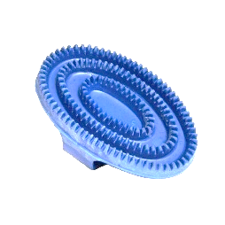
1. Curry Comb: Plastic or rubber comb used in circular motion on the horse to loosen dirt in the horse’s coat. Is not to be used on the face, legs, mane or tail. Care should be used when using over bony protrusions such as withers, shoulder and flank areas. To clean curry comb, tap on a hard surface.

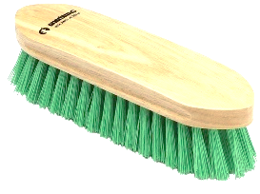
2. Hard Brush: Brush with stiff bristles. It is used to remove the dirt from the horse’s coat brought up by the curry comb. It is used in short, flicking strokes with the same direction as the hair grows. To clean the hard brush, you can take the curry comb over the bristles or use a corner to run across the bristles.
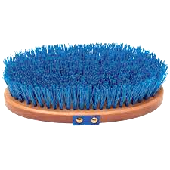

3. Soft Brush: Brush with soft bristles. It is used to remove any missed dirt and smooth and shine the horse’s coat. Use in long strokes the same direction as the hair grows. This can be used on the horse’s face. It is cleaned the same way as the hard brush.

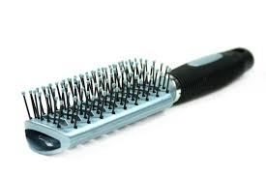
4. Mane and Tail Comb: A plastic handled brush with teeth. It is used to remove tangles from the mane and tail. To comb the tail, NEVER stand behind the horse. Stand beside the hindquarters and bring the tail to you. Always start at the end of the mane or tail and work in small sections.

When starting grooming (either the volunteer or helping a student), greet the horse first. Grooming should be unhurried. Make sure all areas are free and clear of dirt, especially the saddle area and girth area. You should always run your hand around the girth area to make sure it is completely clean. If not, leaving dirt can cause sores. Always ask if you have questions!

Tack

English Saddle Surcingle (Only one handle)
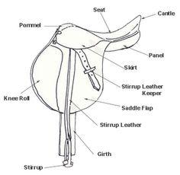
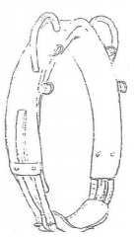

Western Saddle Buddy Saddle
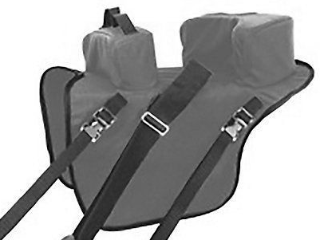
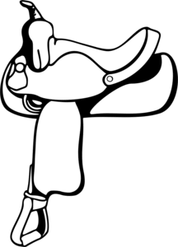

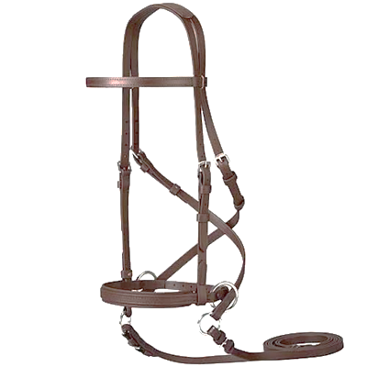
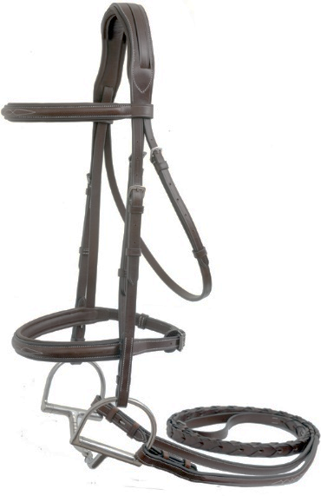

Bitless Bridle Bridle with bit
*Can be put on by *Only instructors
all volunteers put on
*Only the buckle
under the chin
needs done.

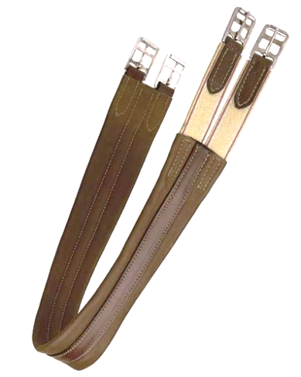

English Girth: there are two styles; elastic on both ends (B)or just one end (A). If the girth has elastic on just one end (A), the elastic end will go on the horse’s left side (near side)
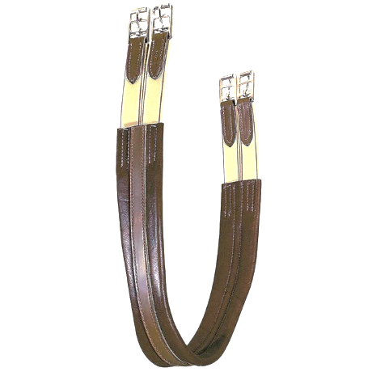
A B

A
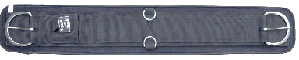
Western Cinch: We have both style A and B here. Style B has a roller that will go on the horse’s left side (near side). This makes tightening the cinch easier to tighten but be aware you can OVER tighten with this.

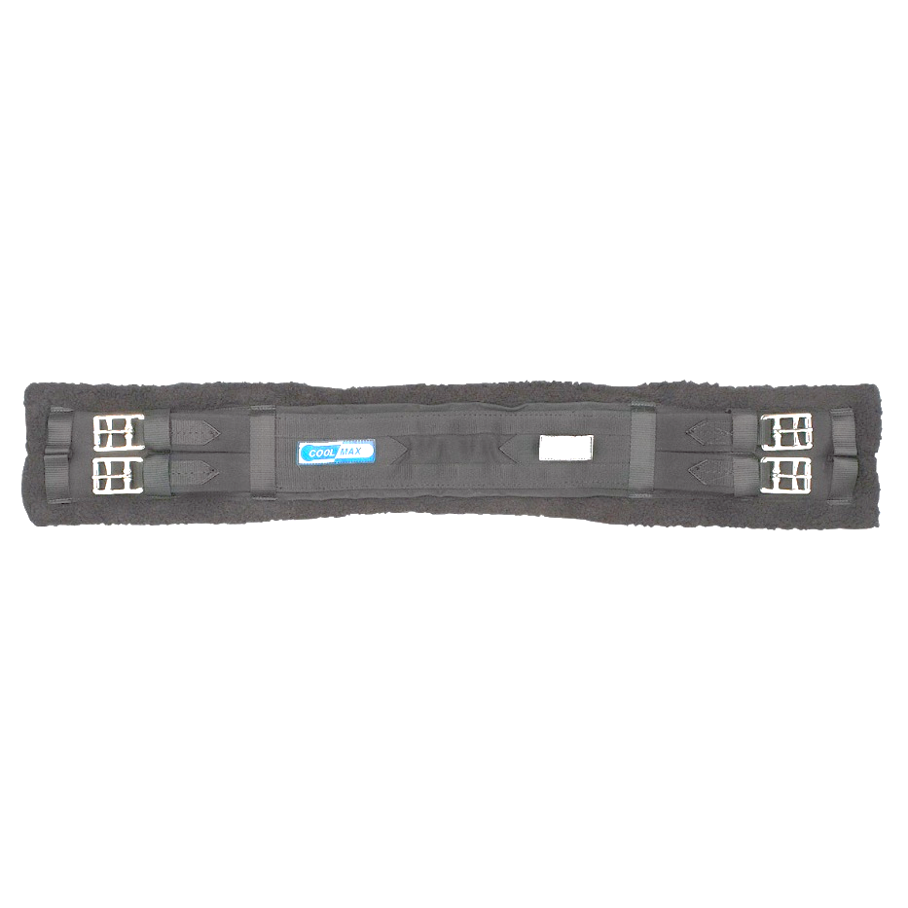

B

Dressage Girth: If you notice the dressage girth has padding under the buckles unlike the English girth.

English Saddle Pad: it doesn’t matter which white English pad you use for the horses.
Western Saddle Pad: The suede portion that is on the top of the pad will be the front. We have short and long pads depending on the horse.

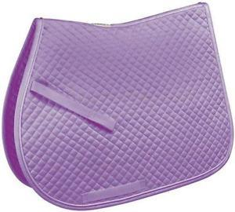
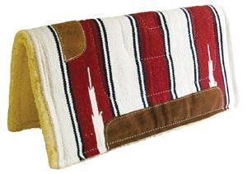

How to Tack
*Some horses are sensitive to getting tacked. Please saddle slowly and DO NOT keep adjusting tack*

1. Place the saddle pad just above the horse’s withers.
2. Add any additional pads on top. If you are unsure, ask the instructor!
3. Place the saddle on top of the pads.
4. Attach the girth/cinch to the horse’s off-side first.
5. On the horse’s near side, run your hand under the girth area to pick up the girth/cinch.
6. When attaching on the near side; if there is a middle ring on the girth/cinch, you want that to be about the middle of the horse. Attach the girth/cinch on the near side – IMPORTANT- DO NOT overtighten the girth/cinch. It should be just tight to keep the saddle in place as the horse walks. The instructor will tack check in the arena. The less readjusting, we have to do with tack the better experience it is for the horse.

Please ask for help if you are unsure! We want grooming and tacking to be a positive experience for our horses.

Emergency Information

Accidents:
When an accident or serious incident occurs in the arena, the instructor working is in charge.
In the event your student should fall, the student is most important. DO NOT MOVE the student. The instructor will direct you to call 911. Please be sure to Make sure the horse is out of the way of the student. Remain calm and do not yell or scream. All horses are to be halted with the leader standing in front of the horse. In the event of a loose horse, DO NOT run at the horse. The instructor will be in charge of catching the loose horse. Side walkers should take care of the student while the leader takes control of the horse. Before volunteers leave, please check in with the instructor as an incident report will be filled out and the instructor will ask volunteers for their statements.

Storms:
At the first occurrence of lightning and/or thunder; all horses will be halted, and riders will be dismounted.

Emergency Dismount:
Should the need arise for an emergency dismount, it is the responsibility of the instructor to perform an emergency dismount. However, if the circumstances are such that the instructor is not close enough to do the emergency dismount it then becomes the responsibility of the side walker.
*If possible, halt the horse. Students should be told to drop the reins, take their feet out of the stirrups (side walkers should help), and then the side walker should put their arm around the student’s waist/under the arms and guide the student off.

Important Emergency Information

Phone Number: 419-756-0040

Address: 569 South Trimble Road

Barn Entrance: 950 Marion Ave

In the event of an emergency, telephones are located in the office.
When calling 911:
- Stay Calm
- Give the location and type of emergency.
- What happened
- The number of victims along with the conditions
- Tell emergency personnel to turn off sirens when they reach the facility to avoid spooking the horses.
- Have someone waiting to direct emergency personnel.

Tornado Warning
- All horses will be halted, and the instructor will dismount all students.
- All riders, parents, and visitors will be led to a safe area.
  - If you are near the main arena: take the steps in the view room to the basement and wait in the meeting room with no windows. If you are unable to get to the basement, go to the interior wall of the mounting area.
  - If you are near the barns: go into the main barn and stay in the feed room and wash rack.
  - If horses are in the arena, they should remain in the arena, with the gate closed.
- All volunteers and instructors should go to the safe area.
- Everyone will remain inside until the warning is over.

Fire
- All horses will be halted, and the instructor will dismount all students.
- The instructor or designee will call 911.
- Sidewalkers should escort the students away from the source of the fire. Everyone should gather in the same location to do a roll call.
- In the event of an arena fire, leaders will take the horses out of either the East or West entrance.
- Leaders and instructors will untack all horses and return to the barn or pasture, away from the fire.

Arena Etiquette
- Always stay at least 2 horse lengths from other horses.
- Come into the center of the arena for a tack check.
- When coming upon a slower rider you can either pass by going to the inside, making a circle or cutting across the arena. Select the best option.
- When passing other riders (slower traffic should stay to the rail or the outside)
  - If coming up behind another horse, you should pass on the inside.
  - If coming face to face with another horse, pass left shoulder to left shoulder which is the same as driving on the road.
- Announce your intentions. If you are unsure what direction the other student and horse are going, call out where you are going – “inside” or “outside.”
Common Terms
Bareback Pad – A thick pad used in place of a saddle.
Cinch – A band attached to a western saddle, used to secure it on a horse by being fastened around the belly.
Crest – The top of the horse’s neck, which the mane grows.
Croup – The topline of the horse’s hindquarters.
Gait – The speed of which a horse travels; walk, trot, canter, gallop.
Girth – A band attached to an English saddle, used to secure it on a horse by being fastened around the belly.
“Inside” – This term is defined by closest to the center of the arena.
Lame – An injury that interferes with the performance or health of the horse.
Latigo – Can either be nylon or leather strap that attaches the cinch to the saddle.
Near Side – The left side of the horse.
Off Side – The right side of the horse.
“Outside” – This term is defined by closest to the rail or outside of the arena.
Tack – Equipment used for riding.
Understand Horse Behavior
Smell – Smell enables a horse to evaluate situations. Allow the horse the opportunity to become familiar with new objects and their environment by smelling.
Hearing – The horse’s hearing is very acute. Forward ears communicate attentiveness and interest. Ears that are laid back communicate they are upset, threatened, or aggressive toward a person or another horse. Ears that flick back and forth indicate attentiveness. If a horse is acting nervous, talk to him in a quiet and calm tone to reassure.
Sight – A horse’s eyes are set on the side of the head which results in good peripheral vision however this creates blind spots directly in front and behind of the horse. A horse will raise or lower its head to focus on objects. Allow a horse to look at new objects.
Touch – Touch is used as communication between horses and between horses and people. Horses are sensitive to soft or rough touch from a person’s hands or legs. A horse’s body is as sensitive as our fingertips. People should treat horses gently but firmly. Be familiar with the horse’s sensitive areas (flank, belly, etc.) Horses can shy at unfamiliar objects. They can also paw at the ground when they are impatient. Do not let the horse paw at the ground if they are impatient.
Taste – Taste is closely linked with smell and helps to distinguish palatable foods and objects. Horses may lick or nibble to become familiar with an object or people. Be careful as this could lead to possible biting. DO NOT put your fingers in the horse’s mouth!
Sixth Sense – Horses do have a “sixth sense” when evaluating the disposition of those around them. Horses can be hypersensitive in detecting moods of people such as anxiety or fear.

Revision Policy
The Volunteer Handbook will be revised on at least a yearly basis, with additions made on an as-needed basis. Revisions are made by the Volunteer Coordinator, and volunteer site supervisors.

We could not do what we do without your commitment and loyalty. On behalf of the entire Raemelton staff, Students, and horses, I want to thank you for all you do. You make such an incredible impact and make such a difference in all our lives. We look forward to another amazing year with you.

Sincerely,

Hannah Nelson
Executive Director

